# Overview of HEDIS/Stars Use Case

Clinical Data Exchange (CDex) aims to improve exchange methods between providers, payers, and other systems to make exchange of health record information more efficient and effective. This allows for improved care coordination, network performance, and delivery of patient care and outcomes, as well reduce the burden of quality reporting.

Payers use clinical information gathered from providers to support the calculation of certain HEDIS measures, some of which are in the Medicare Stars program. The Healthcare Effectiveness Data and Information Set (HEDIS) is made up of standardized performance measures to assess value of care so health plans can be accountable for their performance.

In this InterOpathon, you will use queries to identify whether patients meet the HEDIS/Stars measure.

For a patient’s records to comply with the HEDIS/Stars TRC measure, they must adhere to all four components. Source: <https://www.ncqa.org/hedis/measures/transitions-of-care/>

1. Documentation of receipt of inpatient admission on the day of admission or the following day.
2. Documentation of receipt of discharge information on the day of discharge or the following day.
3. Documentation of patient engagement within 30 days after inpatient discharge (telehealth, visits to the home, office visits, etc.)
4. Medical reconciliation post-discharge 30 days after discharge date (31 total days).

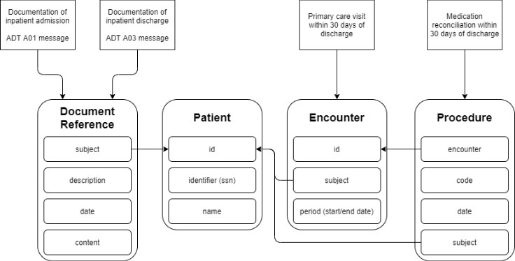

In this TRC, you will explore several scenarios related to patient care records and walk through the requests necessary to find information for several different use cases.

Contents

Overview of HEDIS/Stars Use Case 1

Scenario 1-Determine eligibility of patient for HEDIS TRC criteria using HAPI FHIR® Interface 3

Problem Statement 3

Problem Solution 3

Stakeholder Participation 3

Queries for Scenario 1- Using the HAPI Interface 4

Query 1 – Finding A Patient By SSN 6

Query 2 – Finding Admission Documents by Patient 8

Query 3 – Finding Discharge Documents by Patient 10

Query 4 – Finding Medication Reconciliation Procedures by Patient 11

Scenario 2- Calculating total patients in a health system who meet HEDIS/Stars TRC eligibility criteria 12

Problem Statement 12

Problem Solution 12

Stakeholder Participation 13

Queries for Scenario 2- Using the HAPI FHIR Interface 15

Query 1 – All Admission Documents 15

Query 2 – All Discharge Documents 17

Query 3 – All Medication Reconciliation Procedures 19

REST Client Guide: Performing a Basic Query in Postman for HEDIS/Stars Transition of Care Measure 21

Judging Criteria 23

# Scenario 1-Determine eligibility of patient for HEDIS TRC criteria using HAPI FHIR® Interface

## Problem Statement

Determine whether a patient’s records comply with the measure using the four criteria for the HEDIS/Stars Transitions of Care (TRC) quality measure.

## Problem Solution

**Action**: Use FHIR Resource data and queries to determine if a patient meets the HEDIS TRC qualifications.

**Precondition**: Understand how to use example queries listed below to obtain required data pieces in FHIR Resources.

**Success Criteria**: Accurately identify the number of patients who meet HEDIS TRC qualifications and identify those who do not.

## Stakeholder Participation

Queries you will complete:

* 1. Find a patient ID using SSN.
  2. Find Admission Documents by Patient using DocumentReference.
  3. Find Discharge Documents by Patient using DocumentReference.
  4. Find Medication Reconciliation Procedures by Patient using DocumentReference.

***Tip:*** *Determine if a patient meets the HEDIS TRC measure by using FHIR Resource data*.

|  |  |
| --- | --- |
| **Component for HEDIS/Stars Measure** | **Corresponding FHIR Resource** |
| Documentation of receipt of inpatient admission on the day of admission or the following day. | Documentation of receipt of inpatient admission is represented using a DocumentReference Resource containing an ADT A01 message. |
| Documentation of receipt of discharge information on the day of discharge or the following day. | DocumentReference Resource containing an ADT A03 message. |
| Documentation of patient engagement within 30 days after inpatient discharge (telehealth, visits to the home, office visits, etc.) | Follow-up visit with primary care provider within 30 days of discharge is represented using the Encounter Resource. |
| Medical reconciliation post-discharge 30 days after discharge date (31 total days). | Documented as a Procedure Resource with a Snomed code for Medication Reconciliation procedure: 430193006. |

### Queries for Scenario 1- Using the HAPI Interface

1. After logging into [https://interopland.com](https://interopland.com/login), click the **InterOp PITs** tab to display the PITs in your Sandbox.

***Note:*** *In this scenario you will be using the* ***Five Lakes Health System PIT***.

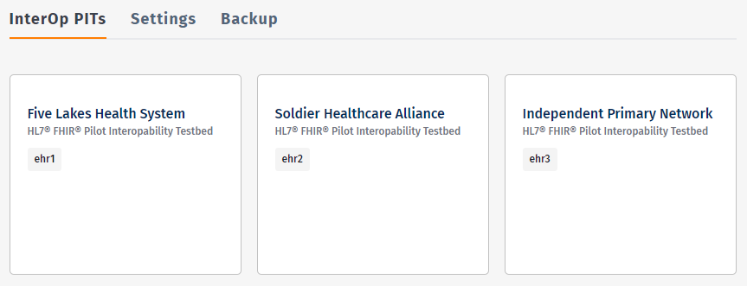

1. Click on the **Five Lakes Health System PIT box** and then the URL in the **Link** section.

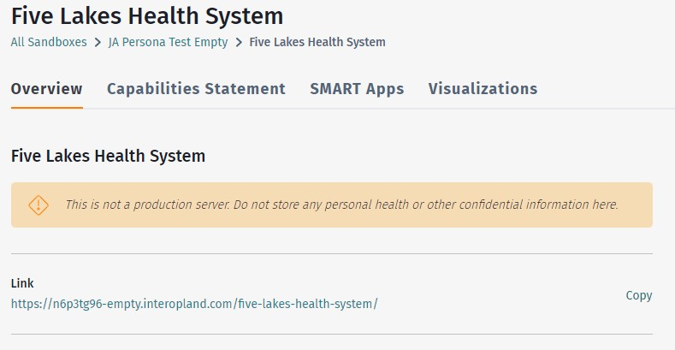

### Query 1 – Finding A Patient By SSN

Because the HAPI FHIR Interface only supports a limited set of search parameters, an additional initial query is necessary to find your Patient record by Social Security Number (SSN). Make a note of the Patient **id** record you find as you will use it in in future queries.

1. Using the left sidebar Resources navigation menu, choose the **Patient** Resource.
2. Using your **Search** **Parameters** arrow choose **identifier – A patient identifier**, verify your search is **Matches**, and then using the **Code** box type the **SSN**. The example below uses SSN 000003044.
3. Click **Search** ().

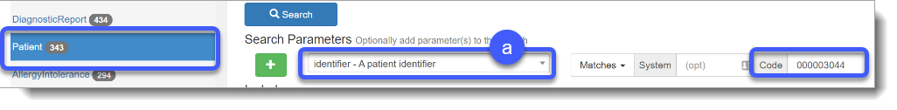

Make a note of your Patient Resource id as you will need it to create more queries later.

1. The query produces the following result which includes the **Result Body** section which returns the number of Bundle entries and Raw Message data.

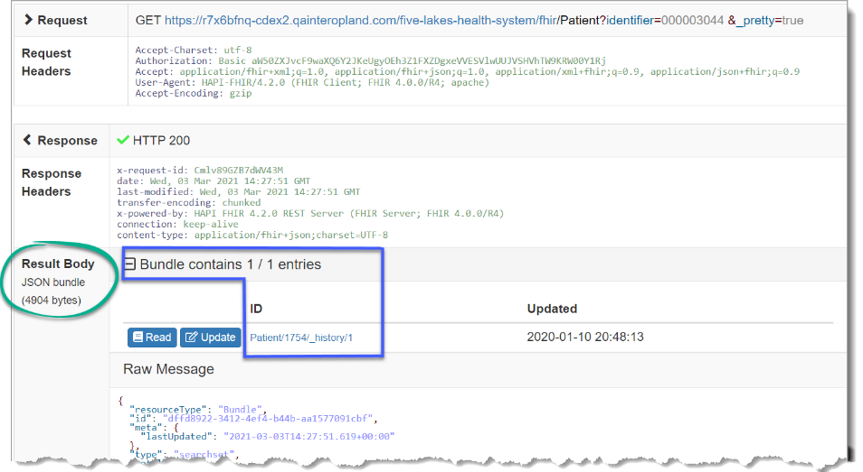The **Result Body** section in this case contains a line at the top that reads **Bundle contains 1 / 1 entries**. This line shows how many results matched the query that was specified.

The first number is the count of results included in this response, the second is the total number of records satisfying that query in this PIT.

When a query matches many records, the numbers can be different because the FHIR server has a limit on the number of records it can return in a single response.

1. Below the Result Body is the **Raw Message** sectionwhich section contains the actual data from your query e.g., a Patient record identified by the supplied SSN.

The **Raw Message** has your detailed patient information, but the focus here is on the **id** number listed under the **Entry** collection. This **id** is a unique identifier for your patient record within the PIT. Other records will use this patient id, so use it to limit searches to only those records relevant to this patient.

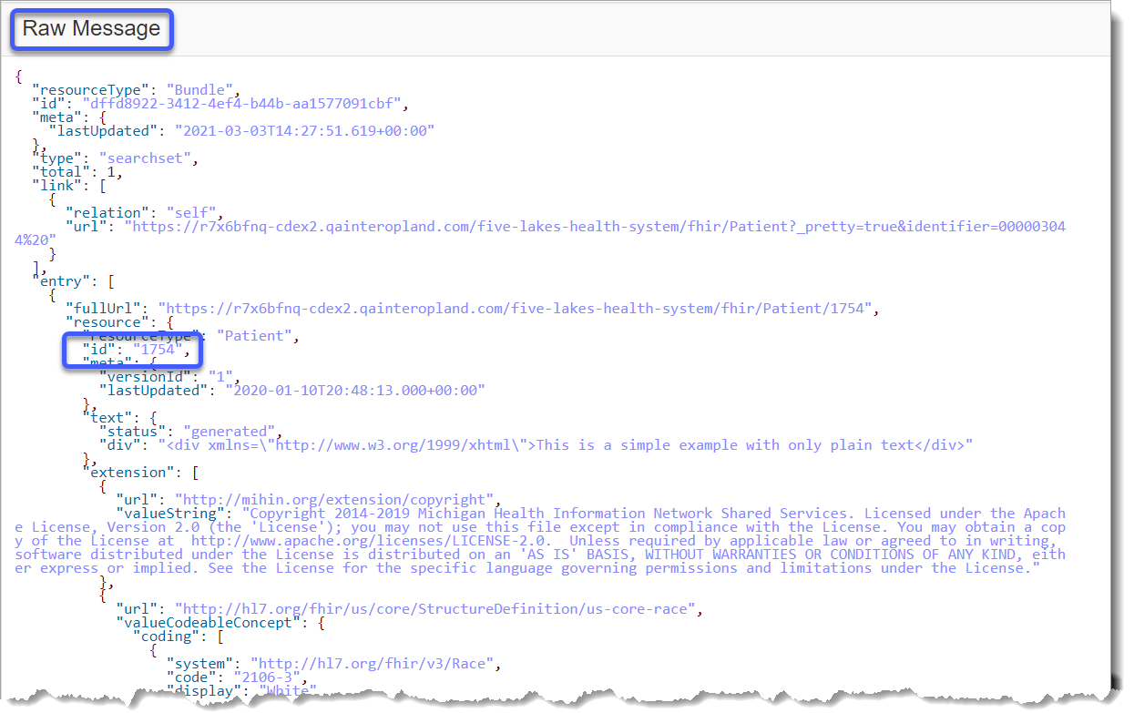

### Query 2 – Finding Admission Documents by Patient

An admission record is represented in this PIT by a **DocumentReference** object containing an ADT A01 message. To locate only the admission documents relevant to a specific patient, you must use two search parameters.

1. Choose **Document Reference** from your left navigation menu.
2. Specify the patient by choosing the **subject – Who/what is the subject of the document** option using your **Search Parameters** arrow, and then type the **id** from your previous query result in the corresponding Resource **id** box.
3. Add a second search parameter for the type of document by clicking the **Add** ().
4. Use your **Search Parameters** arrow to choose the **description – Human/readable description** option.
5. Then type **A01** in the corresponding value box.
6. Click **Search** ().

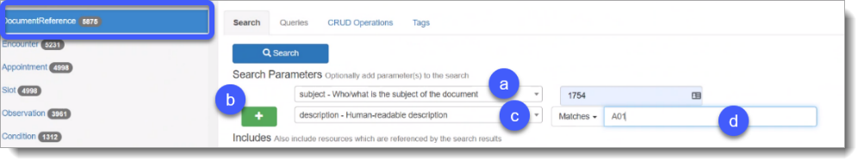

***Note:*** *The query returns a result set in the standard form for the HAPI FHIR interface.*

1. The **Raw Message** section provides the following data.
2. The **lastUpdated** field shows when this document was added to the PIT.
3. The **subject** field contains both the patient’s name and the reference **Patient/1754**, i.e., this document is a Patient with **id** **1754**.
4. The **date** field shows the date the admission occurred.
5. The **data** field contains the encoded original message.

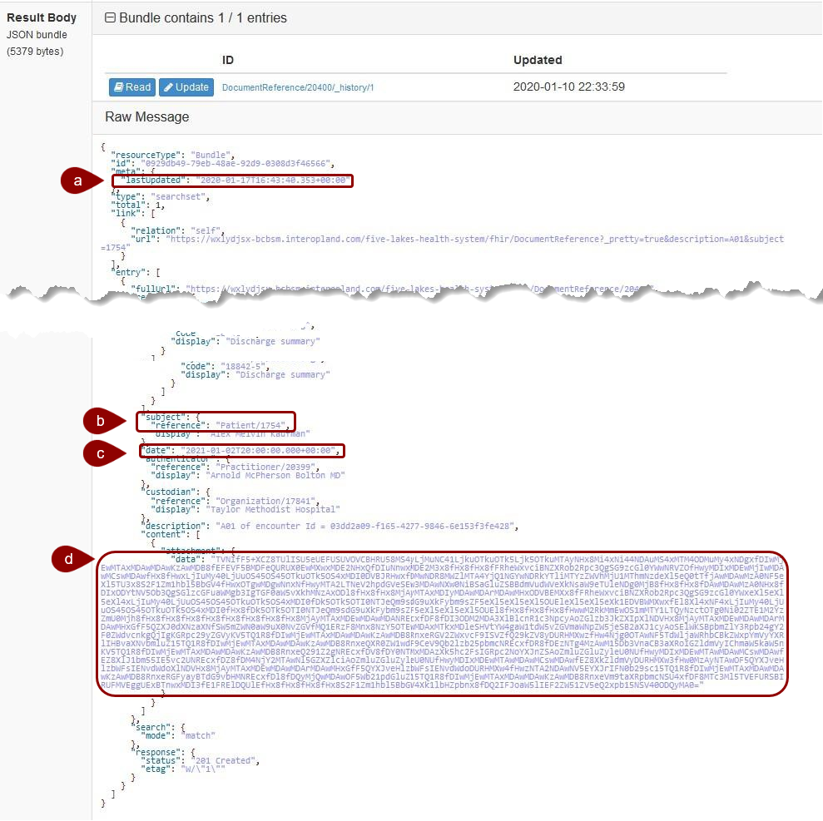

### Query 3 – Finding Discharge Documents by Patient

Like admission records, use the **DocumentReference** Resource with the **subject** and **description** search parameters. Discharge records also contain an ADT A03 message, so add this to the query.

1. 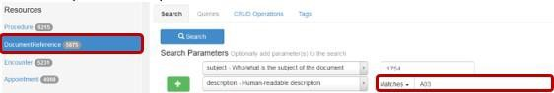The result has the same structure as the admission record query because it uses the same Resource as shown here.
2. The **resourceType** now displays **DocumentReference**.
3. The **date** field displays the patient’s discharge date, establishing the beginning of the 30-day window for the required follow-up visit and Medication Reconciliation procedure to meet the HEDIS quality measure.
4. The **description** displays the ADT **A03** message.
5. 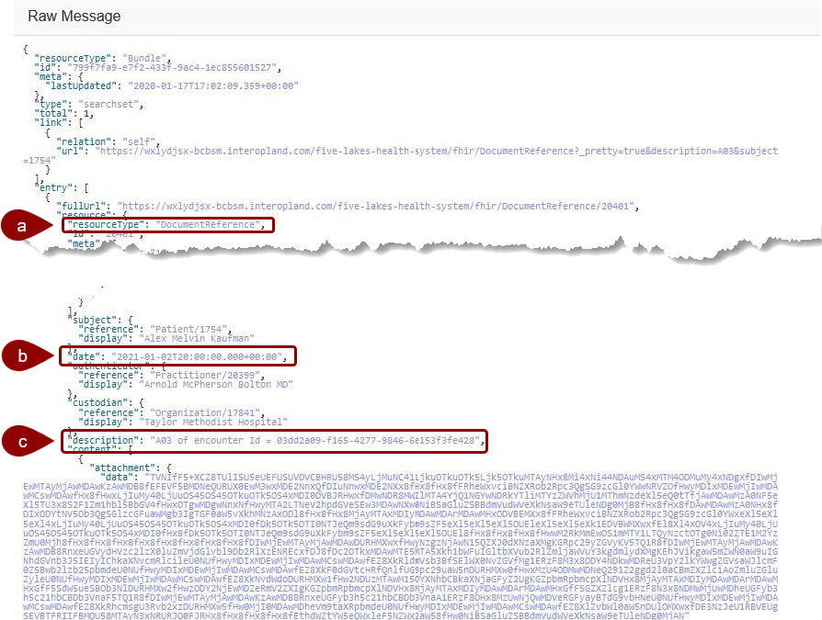Click **Search** ().

### Query 4 – Finding Medication Reconciliation Procedures by Patient

Medication reconciliations are recorded in the **Procedure** Resource.

1. Use the **subject** parameter to specify a patient. The following example uses the same patient as the previous queries, 1754.
2. Choose Procedure from the left Resources navigation menu. Then limit the search results to Medication Reconciliation procedures by using your **Search Parameters** to choose **subject – Search by subject,** Add () another search parameter of **code – A code to identify a procedure** and then type your Snomed code in the corresponding box as 430193006.
3. 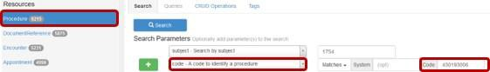Click **Search** ().
4. The result details each procedure that fits the specified criteria.
5. The **resourceType** is Procedure.
6. The Snomed **code** and Medication Reconciliation display.
7. The **performedPeriod** field displays the procedure start date (**start**) and end date (**end**).

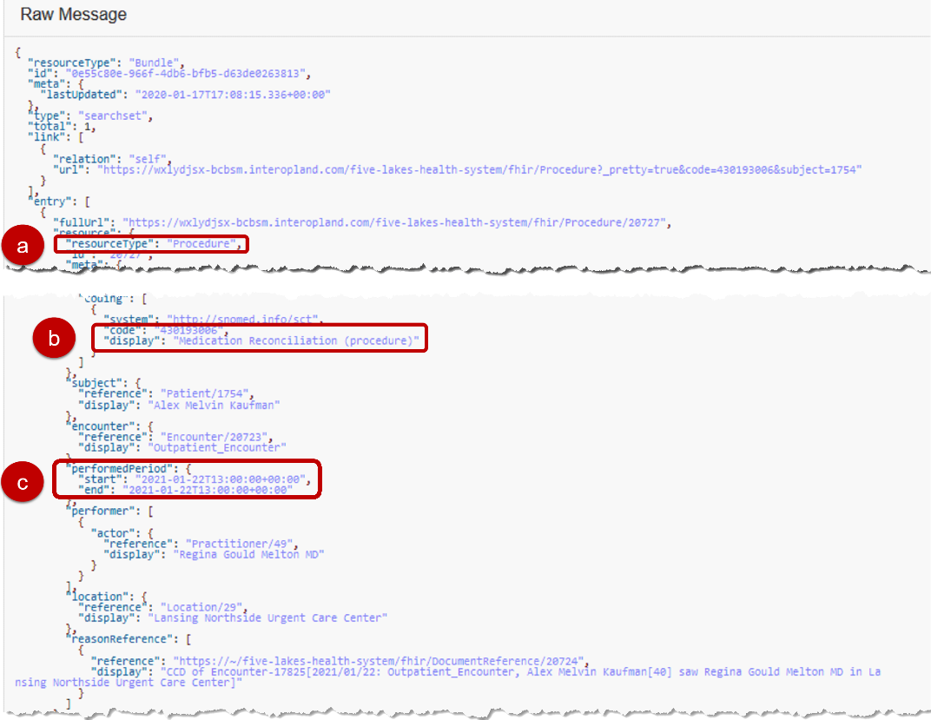To complete the audit for your patient hospital visit, compare the date in the **end** subfield to the date of the patient discharge form. This comparison determines whether the procedure occurred within the 30-day period required by the HEDIS quality measure.

# Scenario 2- Calculating total patients in a health system who meet HEDIS/Stars TRC eligibility criteria

The current validation process for completed HEDIS measures includes querying medical facilities for missing documentation, also known as the “chart chase.” This process requires human intervention to gather additional documentation for audit. The challenge for this scenario is to find cases where the HEDIS criteria are almost met but missing one or more pieces of data.

## Problem Statement

Find the total number of patients who are 18 or older meet one or more of the four components of the measure, but not all. Determine which pieces are missing and report to the provider to request additional documentation.

## Problem Solution

Conceptualize a process that queries the EHR to return the data required for the audit.

1. **Action:** Determine cases where the HEDIS criteria are *almost* met but missing one or more pieces of data.
2. **Precondition**: Understand how to use example FHIR queries listed below to obtain required data pieces.
3. **Success Criteria**: Identifying patients who do not qualify for HEDIS/Stars using FHIR queries, potentially using external APIs and custom code.

## Stakeholder Participation

Queries you will complete:

* + 1. All Admission documents
    2. All Discharge documents
    3. All medication reconciliation procedures

HEDIS TRC – Transitions of Care measure requires four data points:

|  |  |
| --- | --- |
| **Component for HEDIS/Stars Measure** | **Corresponding FHIR Resource** |
| Documentation of receipt of inpatient admission on the day of admission or the following day. | Use a DocumentReference Resource containing an ADT A01 message. |
| Documentation of receipt of discharge information on the day of discharge or the following day. | Use a DocumentReference Resource containing an ADT A03 message. |
| Documentation of patient engagement within 30 days after inpatient discharge (telehealth, visits to the home, office visits, etc.) | Use an Encounter Resource. |
| Medical reconciliation post-discharge 30 days after discharge date (31 total days). | Documented as a Procedure Resource with a Snomed code for Med Reconciliation procedure: 430193006. |

The challenge is to retrieve groups of records for situations where a single piece of data is missing, e.g., the follow-up visit or the medication reconciliation.

***Note****: It may not be possible to retrieve all the necessary data in a single query. You may need to use external APIs and custom code for this scenario****.***

## Queries for Scenario 2- Using the HAPI FHIR Interface

### Query 1 – All Admission Documents

Admission Documents are recorded in the DocumentReference Resource***.***

1. Choose **Document Reference** from your left navigation menu.
2. Use your **Search Parameters** arrow to choose the **description – Human/readable description** option.
3. Type **A01** in the corresponding value box.
4. Since your data may return a large result, you can use the **Sort Results** arrows to sort by field and display in a chosen order.
5. In the **Other Options** section, you can use the **Limit** field value to define the number of results per page.
6. 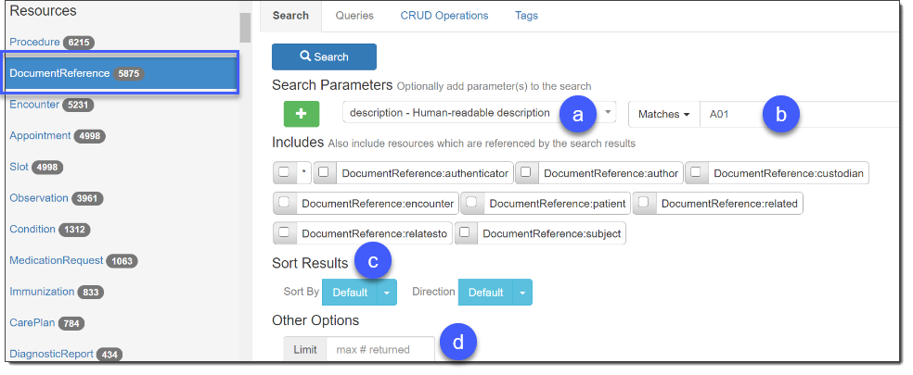Click **Search** ().
7. The **Result Body** displays raw JSON results and individual links to each returned item. Click **Read** to query by **ID** and your results will display in a new window.

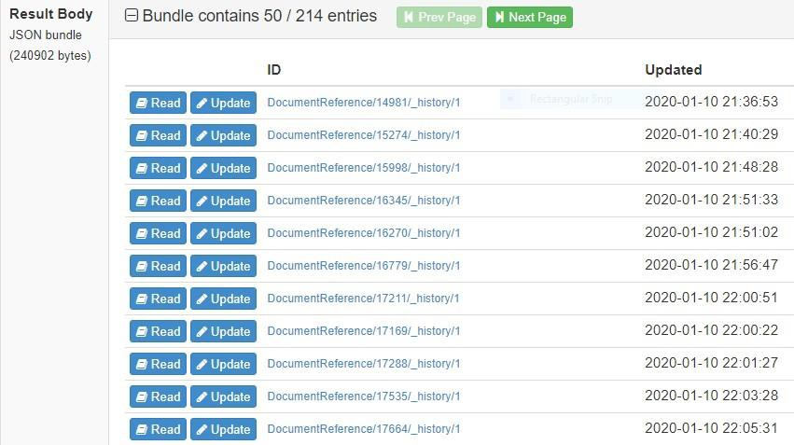

### Query 2 – All Discharge Documents

Querying for the bulk retrieval of discharge documents is almost identical to bulk retrieval of admission documents.

Discharge Documents are recorded in the DocumentReference Resource***.***

1. Choose **Document Reference** from your left navigation menu.
2. Use your **Search Parameters** arrow to choose the **description – Human/readable description** option.
3. Type **A03** in the corresponding value box.
4. Since your data may return a large result, you can use the **Sort Results** arrows to sort by field and display in a chosen order.
5. In the **Other Options** section, you can use the **Limit** field value to define the number of results per page.
6. Click **Search** ().

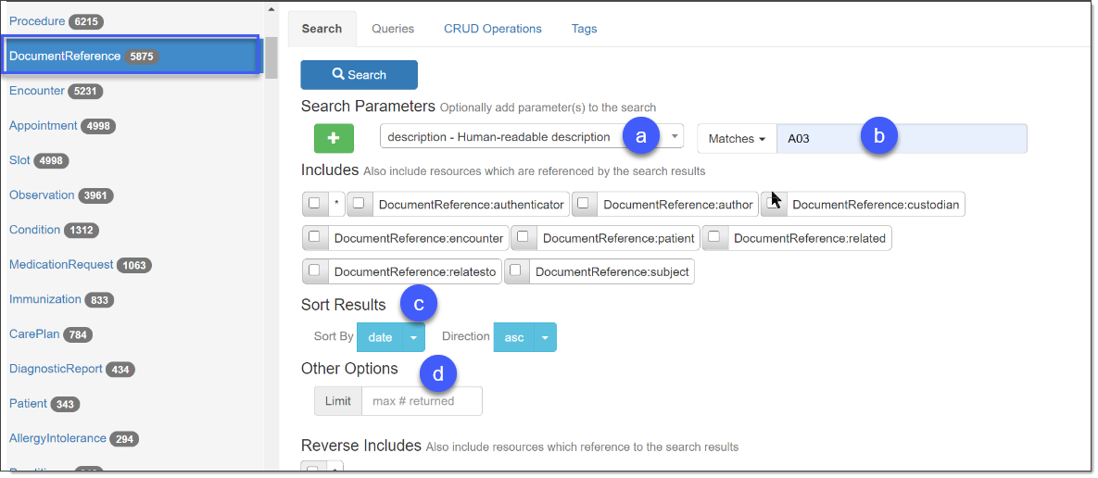

1. The **Result Body** displays raw JSON results and individual links to each returned item. Click **Read** to query by **ID** and your results will display in a new window.

1. Looking at your **Raw Message** you can determine which patients meet the HEDIS measure by discovering:
   1. which patients need to have a medication reconciliation procedure,
   2. and when the 30-day window for each of those procedures began by looking at the **date** data.

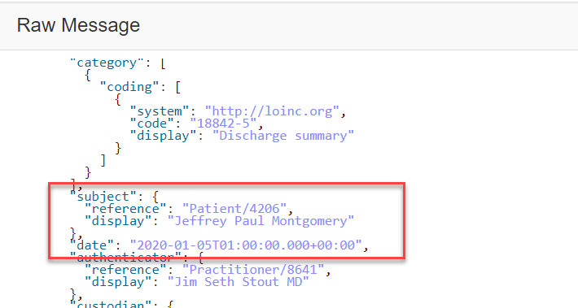

### Query 3 – All Medication Reconciliation Procedures

Querying for all Medication Reconciliation procedures follows the same basic format as the **DocumentReference** bulk queries.

Discharge Documents are recorded in the Procedure Resource***.***

1. Choose **Procedure** from your left navigation menu.
2. Use your **Search Parameters** arrow to choose the **Code- A Code to identify a procedure** option.
3. Type your Snomed **Code** (430193006) in the corresponding box.
4. Since your data may return a large result, you can use the **Sort Results** arrows to sort by field and display in a chosen order.
5. In the **Other Options** section, you can use the **Limit** field value to define the number of results per page.
6. Click **Search** ().

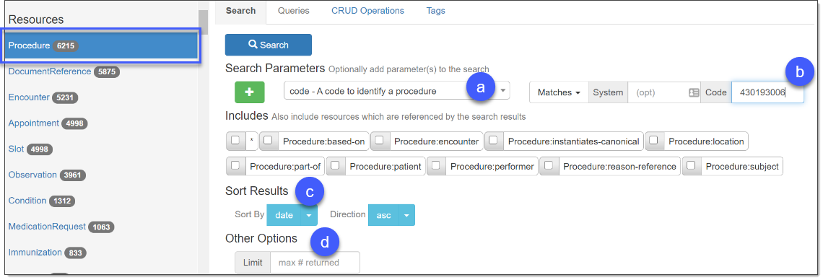

1. The **Result Body** displays raw JSON results and individual links to each returned item. Click **Read** to query by **ID** and your results will display in a new window.

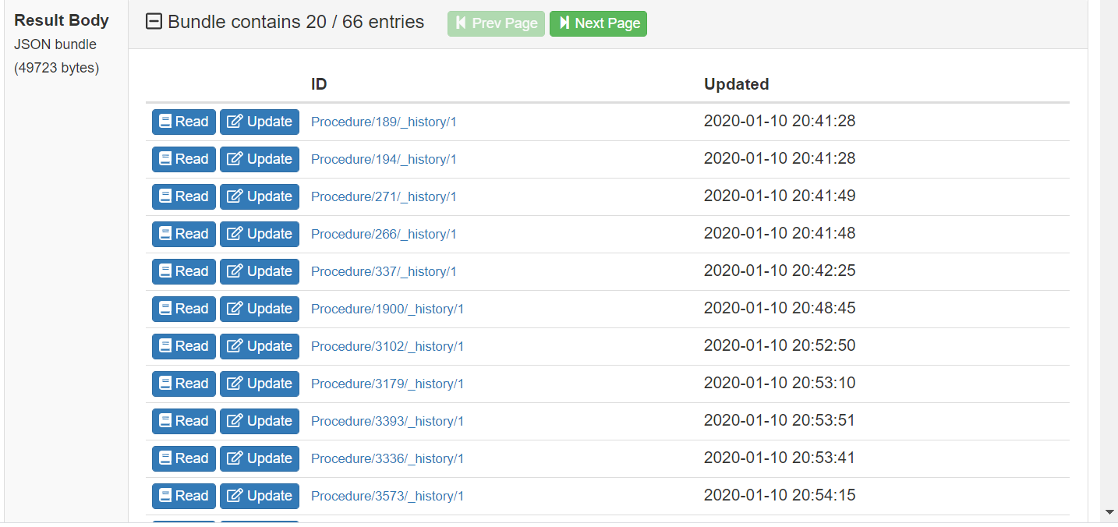

1. Now you can determine HEDIS TRC compliance by comparing the Medication Reconciliation procedures returned by this query to the list of discharge documents returned by the previous one.

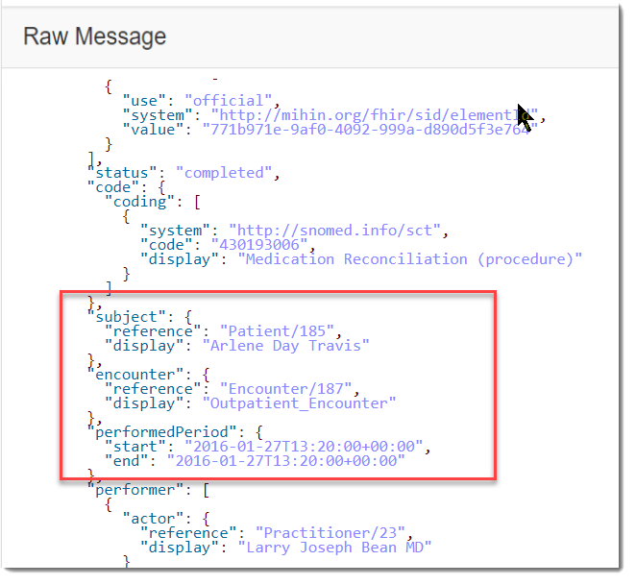***Note:*** *The patient’s displayed name in the subject field is not guaranteed to be unique, so comparisons should rely on the* ***reference*** *id instead.*

### REST Client Guide: Performing a Basic Query in Postman for HEDIS/Stars Transition of Care Measure

Postman is a tool for API testing which organizes HTTP requests before sending them to a server. Use it as an alternative to the front-end query tool.

***Tip:*** *Using Postman and the RESTful API, it is possible to create more complex queries. Please refer to the Interoperability Land User Guide, Appendix B: Querying FHIR Resources for details.*

1. Identify the **URL** for the relevant FHIR PIT as shown below.

https://<<Interoperability Land PIT details>>.interopland.com/<<FHIR-PIT-NAME>>/FHIR/Patient?identifier=000003142

The PIT’s **Link**, **Username** and **Password** are found in the Interoperability Land PIT **Overview** tab.

***Note:*** *Copy the PIT details on the Interoperability Land interface for a complete URL.*

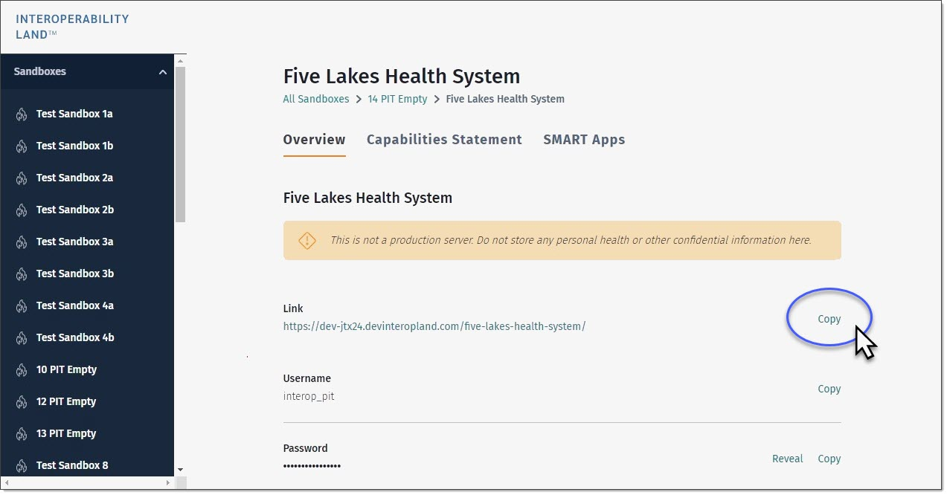

1. Next, set up authorization in Postman. In the **Authorization** tab, set the **TYPE** to **Basic Auth** and enter the PIT’s **Username** and **Password**.
2. 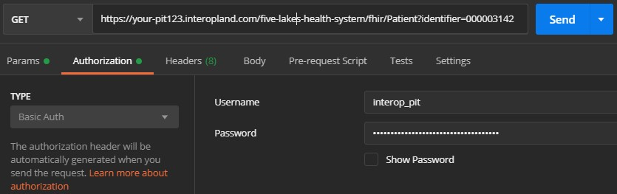Click **Send** to generate and send an HTTP GET request to the server to query for any **Patient** Resources with an identifier of 000003142.

# Judging Criteria

Judging criteria vary according to event. Refer to the judging criteria distributed for your event.